Assignment 1: Network Consultation for DesignIT
This assignment contains two (2) Sections: Network Consultation Proposal and Network Consultation Presentation. You must submit both sections as separate files in order to complete this assignment.
The owners of DesignIT, who recently purchased 56'x36' space for their expanding business, have asked you to place a bid on a consulting job. DesignIT is a graphic arts company that, up until now, had contracted work out to temporary design services. The new space will allow them to hire two (2) full time designers and a receptionist.
Description of space purchased:
- 4 Cubicles
- 1 Office
- 1 Server room
- 1 Reception desk
- 1 Conference room
Below is the design of the space purchased:
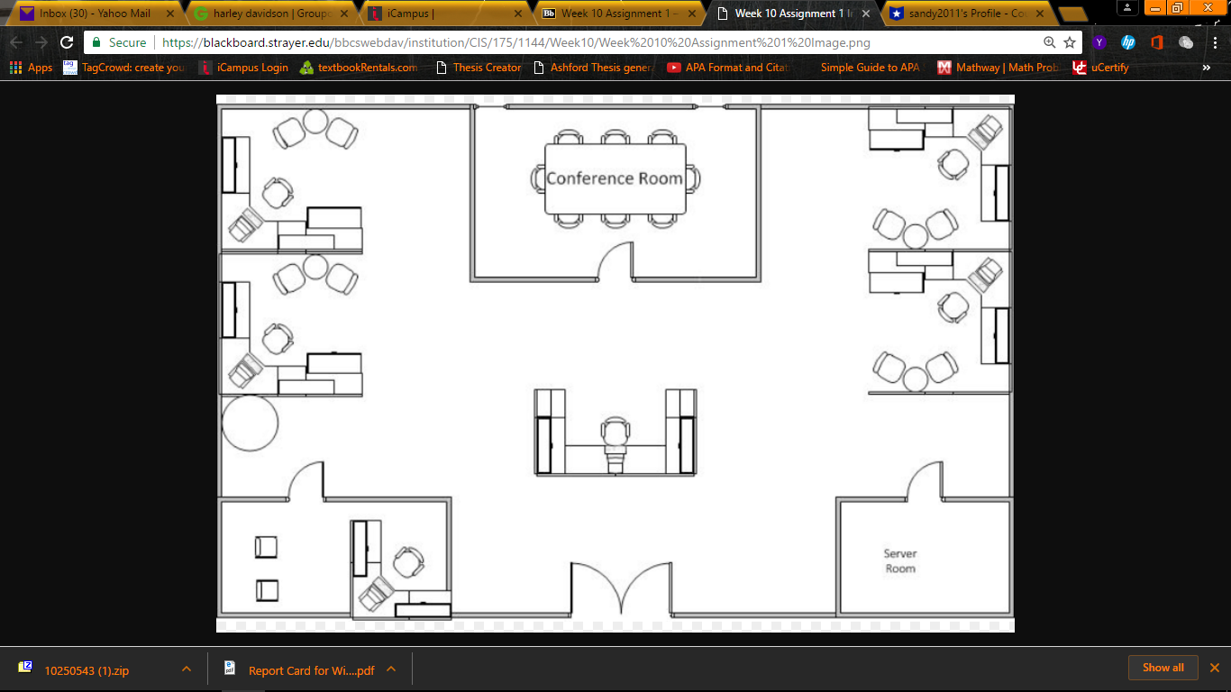

Click here if you are having trouble viewing the above image.
Using the building layout, your role is to provide DesignIT with a network design that interconnects the following considerations:

- DesignIT plans to relocate three (3) servers already configured as follows:
  - 1 Web Server – Microsoft IIS Server
  - 1 File Server – Microsoft Server 2008
  - 1 Server – Server 2008 Small Business Server
- DesignIT has requested that the design include the following:
  - High speed Internet access
  - Firewall
  - Antivirus / malware protection
  - Six (6) computers
  - Three (3) color laser printers
  - Wireless access for portable devices
- DesignIT has requested the consideration of all interconnected devices and wiring, along with speeds, for best performance.
Section 1: Network Consultation Proposal
(Microsoft Word)
Create a cost analysis, and develop a proposal for the company.
- Write a five to seven (5-7) page proposal in which you:
  - Recommend one (1) suitable network design.
  - Suggest one (1) network architecture.
  - Suggest LAN and Wireless LAN (WLAN) wiring considerations.
  - Recommend hardware options and costs.
  - Suggest security considerations for:
    - Firewall
    - Antivirus software
  - Recommend software options and costs.
  - Outline the labor costs, equipment costs, and service costs for your suggested design in table format.
  - Identify the single point of failure, and recommend potential mitigation strategies.
  - Use at least three (3) quality resources in this assignment. Note: Wikipedia and similar Websites do not qualify as quality resources.
Section 1 of your assignment must follow these formatting requirements:

- Be typed, double spaced, using Times New Roman font (size 12), with one-inch margins on all sides; citations and references must follow APA or school-specific format. Check with your professor for any additional instructions.
- Include a cover page containing the title of the assignment, the student’s name, the professor’s name, the course title, and the date. The cover page and the reference page are not included in the required assignment page length.
Section 2: Network Consultation Presentation
(Microsoft PowerPoint or equivalent)

Use Microsoft PowerPoint or an open source alternative to present your findings to the client.
- Create a five to ten (5-10) slide presentation in which you:
  - Outline the recommendations from your written proposal in Section 1.
  - Provide general speaking notes that you would use to highlight non-visual content.
The specific course learning outcomes associated with this assignment are:

- Explain the basic components and media of network systems and distinguish between LANs, MANs, and WANs.
- Summarize current networking standards and how standards bodies and the standardization process impact networking technology.
- Describe the TCP / IP protocols and various functions among the application layer.
- Contrast why different technologies are deployed in different contexts of networking, such as topology, bandwidth, distance, and number of users.
- Explain and differentiate among network hardware devices and components.
- Compare and contrast among network operating systems.
- Describe security policy, practices, encryption techniques, and design considerations in support of business operations in a networked environment.
- Explain the role of integrity and availability in a networked environment.
- Use technology and information resources to research issues in computing networks.
- Write clearly and concisely about introductory networking topics using proper writing mechanics and technical style conventions.
Grading for this assignment will be based on answer quality, logic / organization of the paper, and language and writing skills, using the following rubric:

Points: 200 | Assignment 1: Network Consultation for DesignIT
Criteria | Unacceptable  Below 60% F | Meets Minimum Expectations  60-69% D | Fair  70-79% C | Proficient  80-89% B | Exemplary  90-100% A
1. Write an five to seven (5-7) page proposal in which you:
1a. Recommend one (1) suitable network design.  Weight: 10% | Did not submit or incompletelyrecommended one (1) suitable network design. | Insufficiently recommended one (1) suitable network design. | Partially recommended one (1) suitable network design. | Satisfactorily recommended one (1) suitable network design. | Thoroughly recommended one (1) suitable network design.
1b. Suggest one (1) network architecture.  Weight: 10% | Did not submit or incompletelysuggested one (1) network architecture. | Insufficiently suggested one (1) network architecture. | Partially suggested one (1) network architecture. | Satisfactorily suggested one (1) network architecture. | Thoroughly suggested one (1) network architecture.
1c. Suggest LAN and Wireless LAN (WLAN) wiring considerations.  Weight: 10% | Did not submit or incompletelysuggested LAN and Wireless LAN (WLAN) wiring considerations. | Insufficiently suggested LAN and Wireless LAN (WLAN) wiring considerations. | Partially suggested LAN and Wireless LAN (WLAN) wiring considerations. | Satisfactorily suggested LAN and Wireless LAN (WLAN) wiring considerations. | Thoroughly suggested LAN and Wireless LAN (WLAN) wiring considerations.
1d. Recommend hardware options and costs.  Weight: 8% | Did not submit or incompletely recommended hardware options and costs. | Insufficiently recommended hardware options and costs. | Partially recommended hardware options and costs. | Satisfactorily recommended hardware options and costs. | Thoroughly recommended hardware options and costs.
1ei. Suggest security considerations for firewall implementation.  Weight: 4% | Did not submit or incompletely suggested security considerations for firewall implementation. | Insufficiently suggested security considerations for firewall implementation. | Partially suggested security considerations for firewall implementation. | Satisfactorily suggested security considerations for firewall implementation. | Thoroughly suggested security considerations for firewall implementation.
1eii. Suggest security considerations for antivirus software implementation.  Weight: 4% | Did not submit or incompletely suggested security considerations for antivirus software implementation. | Insufficiently suggested security considerations for antivirus software implementation. | Partially suggested security considerations for antivirus software implementation. | Satisfactorily suggested security considerations for antivirus software implementation. | Thoroughly suggested security considerations for antivirus software implementation.
1f. Recommend software options and costs.  Weight: 8% | Did not submit or incompletely recommended software options and costs. | Insufficiently recommended software options and costs. | Partially recommended software options and costs. | Satisfactorily recommended software options and costs. | Thoroughly recommended software options and costs.
1g. Outline the labor costs, equipment costs, and service costs for your suggested design in table format.  Weight: 8% | Did not submit or incompletely outlined the labor costs, equipment costs, and service costs for your suggested design in table format. | Insufficiently outlined the labor costs, equipment costs, and service costs for your suggested design in table format. | Partially outlined the labor costs, equipment costs, and service costs for your suggested design in table format. | Satisfactorily outlined the labor costs, equipment costs, and service costs for your suggested design in table format. | Thoroughly outlined the labor costs, equipment costs, and service costs for your suggested design in table format.
1h. Identify the single point of failure, and recommend potential mitigation strategies.  Weight: 8% | Did not submit or incompletely identified the single point of failure, and did not submit or incompletely recommended potential mitigation strategies. | Insufficiently identified the single point of failure, and insufficiently recommended potential mitigation strategies. | Partially identified the single point of failure, and partially recommended potential mitigation strategies. | Satisfactorily identified the single point of failure, and satisfactorily recommended potential mitigation strategies. | Thoroughly identified the single point of failure, and thoroughly recommended potential mitigation strategies.
1i. 3 references  Weight: 5% | No references provided | Does not meet the required number of references; all references poor quality choices. | Does not meet the required number of references; some references poor quality choices. | Meets number of required references; all references high quality choices. | Exceeds number of required references; all references high quality choices.
2. Create a five to ten (5-10) slide presentation in which you:
2a. Outline the recommend-ations from your written proposal in Section 1.  Weight: 10% | Did not submit or incompletely outlined the recommend-ations from your written proposal in Section 1. | Insufficiently outlined the recommendations from your written proposal in Section 1. | Partially outlined the recommend-ations from your written proposal in Section 1. | Satisfactorily outlined the recommend-ations from your written proposal in Section 1. | Thoroughly outlined the recommend-ations from your written proposal in Section 1.
2b. Provide general speaking notes that you would use to highlight non-visual content.  Weight: 5% | Did not submit or incompletely provided general speaking notes that you would use to highlight non-visual content. | Insufficiently provided general speaking notes that you would use to highlight non-visual content. | Partially provided general speaking notes that you would use to highlight non-visual content. | Satisfactorily provided general speaking notes that you would use to highlight non-visual content. | Thoroughly provided general speaking notes that you would use to highlight non-visual content.
3. Clarity, writing mechanics, and formatting requirements
3. Clarity, writing mechanics, and formatting requirements  Weight: 10% | More than 8 errors present | 7-8 errors present | 5-6 errors present | 3-4 errors present | 0-2 errors present

